**Live-in-Labs® : Field Visit to Thaichiyam, Ramanathapuram**

**Activity Category :** Self – Driven Activities

**Event Title :** Live-in-Labs : Field Visit

**Dates :** 22/12/2024 - 29/12/2024 (LILA-I ) & 24/04/2025 – 01/05/2025 (LILA-II)

**Occasion/Theme :** Experiential Learning

**Organized by :** Live-in-Labs, Amrita Vishwa Vidyapeetham

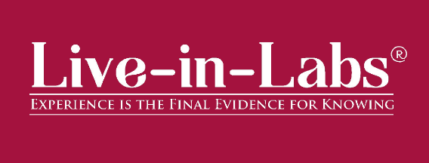

**Overview**

The Live-in-Labs® project in **Kalaignar Nagar(Rameshwaram)** was carried out by a team of Amrita students and international students under the mentorship of **Dr. Sampath Kumar S**. The focus of the visit was to address the challenge of neglected mental health in children within the rural community of Kalaignar Nagar through innovative, sustainable, and community-driven solutions.

The team interacted with villagers, conducted surveys, and studied the socio-economic conditions to identify root causes of the problem. Based on this, solutions such as Medical Camps for mental and physical health screening Cognitive Enrichment Activities involving puzzle-solving and behavioural games These interventions combine scientific knowledge with frugal innovation, making them both cost-effective and scalable.

The visit provided the team with hands-on exposure to applying classroom concepts in real-world contexts. Students gained valuable knowledge on design thinking, grassroots innovation, and community engagement. The collaboration between Amrita and international students enriched the process with diverse perspectives, ensuring that the solutions were both technically sound and socially acceptable.

Overall, the project demonstrated how grassroots challenges can be transformed into opportunities for innovation and entrepreneurship. The solutions identified have the potential for further prototyping, incubation, and replication in other rural contexts, aligning with the vision of IIC to foster innovation-driven impact.

**Planning & Execution**

The project was planned in advance based on the schedule prepared and submitted during the Live-in-Labs® workshop. The schedule served as a roadmap, outlining each stage of the work from preliminary study to field immersion and final reporting. In the initial phase, the team conducted a background study of the village and gathered secondary data to understand the broader context of the problem. This was followed by structured planning of surveys, community interactions, and technical assessments, all aligned with the timelines agreed upon.

Live-in-Labs®-I Schedule:

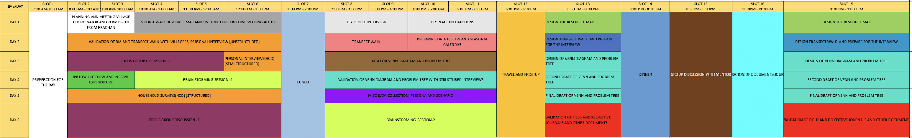

Live-in-Labs®-II Schedule:

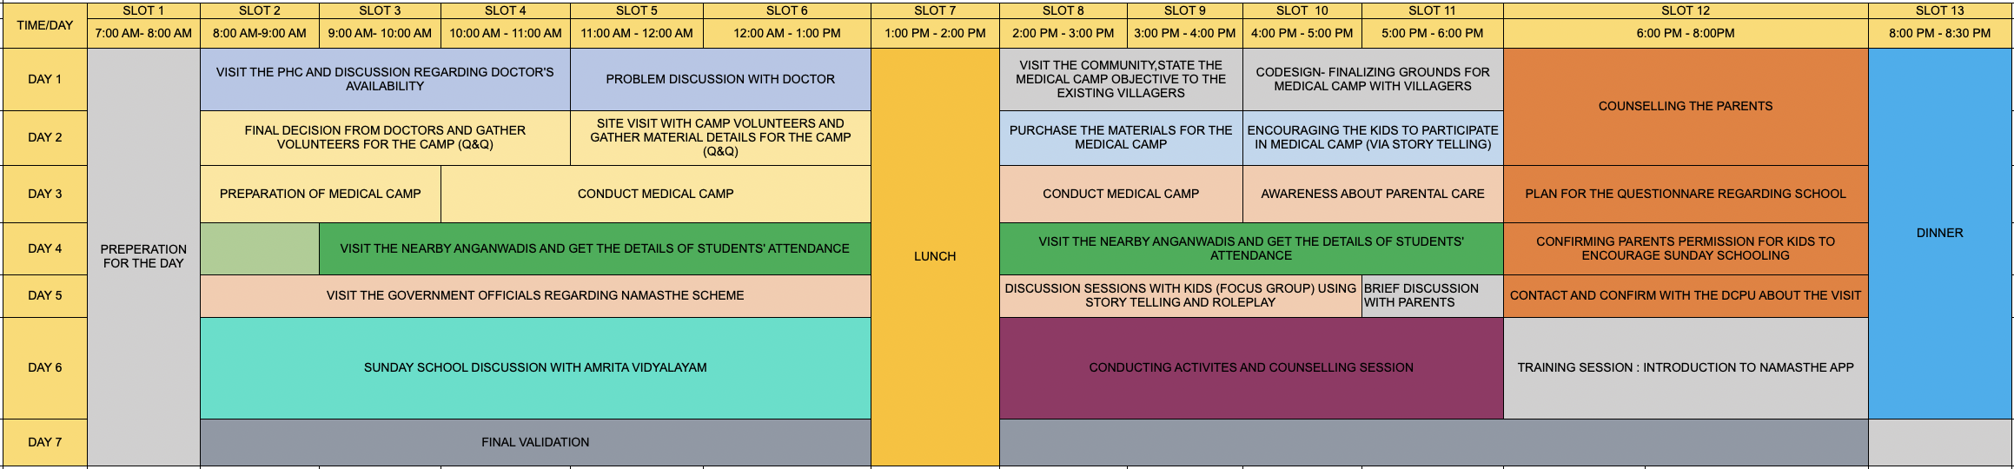

**Impact & Outcomes**

* **Innovation :**The project demonstrated how grassroots challenges can inspire innovative, frugal solutions. By integrating scientific concepts with local knowledge, the team designed interventions such as Medical Camps for early mental and physical health screening and Cognitive Enrichment Activities involving focus-based games and puzzle-solving that were low-cost, adaptable, and scalable. This process highlighted the power of student-led innovation to create practical and impactful models in rural development.
* **Design Thinking :** The outcomes of the project were achieved by following a design-thinking approach. Students empathized with villagers through surveys and discussions, defined the root problems, ideated possible solutions, and tested their feasibility with the community. This systematic method ensured that the solutions were not only technically feasible but also socially acceptable and context-specific.
* **Entrepreneurship Potential :** Several proposed solutions have the potential to evolve into entrepreneurial models or startups. For example,the mental health screening tool designed for teachers and healthcare workers can be further developed into a product or service that benefits multiple villages, creating employment opportunities while addressing community needs. This outcome aligns with IIC’s vision of nurturing student entrepreneurship and translating innovation into scalable ventures.
* **Sustainability :** The solutions emphasized long-term sustainability by making use of locally available resources and building capacity within the community. As a result, the interventions can be maintained by villagers themselves without heavy dependence on external support. This ensures that the outcomes continue to create impact even after the project phase ends.
* **Societal Impact :** The immediate impact of the project was raising awareness among community members about alternative and innovative practices. In the long run, the solutions are expected to improve living standards, reduce resource-related hardships, and strengthen the resilience of the village. The project also encouraged local youth to view innovation as a tool for solving their own challenges.
* **Collaboration and Knowledge Sharing :** A significant outcome of the project was the knowledge exchange that took place between Amrita students, international peers, and the local community. This cross-cultural collaboration enriched the learning experience, allowed multiple perspectives to be considered, and helped design solutions that were technically sound, socially relevant, and globally informed.

**Participation**

1. **Student Members:** Conducted Surveys, Identified the Problem and Designed Solutions.

* Sudharsan Vanamali (CB.EN.U4CSE22049) - Dept. of Computer Science and Engineering.
* Kurapati Venkata Lakshmi Narasimha Kushal (CB.EN.U4CSE23525) - Dept of Computer Science and Engineering
* Kamali Harshini (CB.EN.U4EEE22114 - Dept of Electrical and Electronics Engineering
* G Sravanthi (CB.EN.U4CSE22014) - Dept of Computer Science Engineering
* S Pranay - Dept of Computer Science Engineering
* Tanushri Ravish (CB.EN.U4EEE23050) - Dept of Electrical and Electronics Engineering
* A Sreenidhi - Dept of Electrical and Electronics Engineering
* S Dhivyaa Sakthi - Dept of Mechanical Engineering
* K Praveen - Dept of Electrical and Electronics Engineering

**Contribution to SDGs**

The project contributes to several United Nations Sustainable Development Goals (SDGs):

* **SDG 3 : Good Health and Well-being** – By implementing mental and physical health screening camps and early detection tools, the project promotes the health and well-being of children in rural communities.
* **SDG 4 : Quality Education** – Through addressing barriers like unsafe travel and poor health affecting school attendance, and promoting cognitive enrichment activities, the project enhances access to quality education.
* **SDG 6 : Clean Water and Sanitation** – The project emphasizes improving hygiene and sanitation infrastructure, reducing health risks related to poor sanitation, and indirectly improving educational access.
* **SDG 8 : Decent Work and Economic Growth** – By engaging with government schemes and creating scalable intervention models, the project supports pathways for sustainable economic development and potential entrepreneurial ventures.
* **SDG 10 : Reduced Inequalities** – Targeting marginalized children, especially those with mental health challenges and from low socio-economic backgrounds, the project promotes inclusion and reduces inequalities in access to healthcare and education.
* **SDG 17 : Partnerships for the Goals** – The project demonstrates collaboration between academic institutions, government bodies, local communities, and international peers, creating a model of knowledge sharing and collective action toward sustainable development.

**Relevant Images**

